ModeFair Assessment Report

by LING XING MOU

**Idea**

This is actually a famous problem called the Capacitated Vehicle Routing Problem (CVRP). To solve this problem, we can split the problem into 2 parts. The first part is to find the clusters that represent group of customers visited by a vehicle in a single route. Then, as the second part, we can solve the Travelling Salesman Problem (TSP) for each cluster.

To select a metaheuristic optimization algorithm, a paper is published in year 2022 to compare the mainstreams of metaheuristic approaches on the travelling salesman problem, which are Genetic Algorithm (GA), Simulated Annealing (SA), Tabu Search (TS), Ant Colony Optimization (ACO), and Particle Swarm Optimization (PSO). Eventually, the ACO method is choosen. It is an algorithm that based on the idea of mimicking the behavior of ants to find the shortest paths to the food sources. The ants will leave pheromones in the paths they travelled. The shorter a path is, the faster the ants will get to the food source by using the path, the greater the pheromone in the path. Based on the result presented in the paper mentioned above, ACO is more consistent compared to other algorithms, at the same time having great efficiency and quality of solutions.

**Code Implementations**

Based on the idea, we have two major parts of the codes to solve the problem.

Cluster the Customers

To create clusters, there are two main steps:

1. Create initial clusters based on the customer coordinates and capacity limits.
   1. Create a cluster with a single point randomly chosen from the customer points.
   2. Assign the closet point among the unclustered points to the cluster, until the cluster is unable to hold the new closet point.
   3. Create a new cluster and repeat the process until all points are clustered.
2. Refine the initial clusters to obtain the shorter travelling salesman route.
   1. For each point in the customer points, check its distance to the center of all of the clusters.
   2. If the point is closer to a cluster that it is not currently in, reassign the point to the closer cluster if the cluster has enough capacity.
   3. Repeat the process for few iterations to find a relatively good solution.

The two main steps are executed for different values of capacity limit.

Ant Colony Optimization

To solve TSP problem by using ACO, the steps are:

1. Calculate the distance matrix.
2. Initialize the pheromone matrix to be identical to each path.
3. Initialize a population of ants that start at the depot.
4. The ants will move with randomness based on the pheromone and distance to the next point, until they visited all of the points.
5. Each ant in the population will leave certain amount of pheromone in the path it travelled, based on the total distance of the path. The pheromone will also evaporate over time.
6. The process will be repeated with new populations of ants for a number of iterations.
7. The shortest path and cost will be recorded during the process.

I executed the ACO algorithm on all cluster results of different capacity limits, and compare their cost to find the best cluster result with the best routes. The hyperparameter values are set based on the recommended default values in the paper.

**Example Result**

The integers in the routes represents the index of the point in customer coordinates, with depot added as the first point.

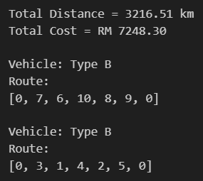 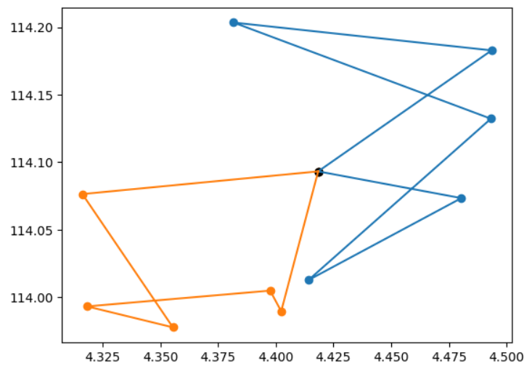

**References**

Tosoni, D., Galli, C., Hanne, T., & Dornberger, R. (2022). Benchmarking metaheuristic optimization algorithms on travelling salesman problems. *2022 8th International Conference on E-Society, e-Learning and e-Technologies (ICSLT)*. https://doi.org/10.1145/3545922.3545926